Select one of the following three questions (Q9, Q10, or Q11) to answer. Be sure to mark the “Select” circle  corresponding to the question that you select to answer on your answer sheet.
Note that if you select two or more questions, only the first question that you select will be scored.

Q9. Read the following description of a C program and the program itself, and then answer sub-questions 1 through 4.

[Program Description]
A function DrawCurve was created to draws a free curve between point S at coordinates (sx, sy) and point E at coordinates (ex, ey) on the screen through approximation by using a sequence of minute line segments. In order to determine the shape of the curve, two control points are specified as parameters: C1 at coordinates (x1, y1) and C2 at coordinates (x2, y2). The polygonal curve that is formed by the four points given as shown in the figure is then divided recursively, and the final series of straight line segments are drawn when the convergent condition determined by the parameter len (len > 2) is met.

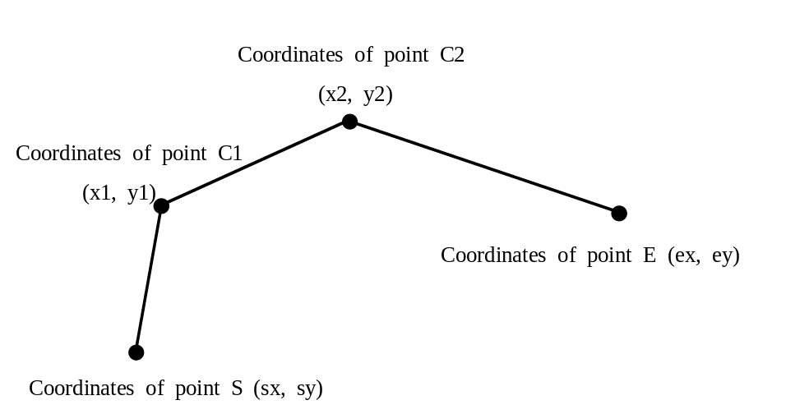
(The enlarged dots • are intended as a symbol that indicates the coordinates of a point,
and are not drawn by the program).
Fig. Coordinates of the Four Points Given

The prototype for the function DrawCurve is as follows:
void DrawCurve( int sx, int sy, int x1, int y1, int x2, int y2,
int ex, int ey, int len ) ;
The relationship between the parameters and the point coordinates is shown in the figure.
The following two functions are provided for the purpose of drawing straight segment that connect two points:

void MoveTo( int sx, int sy ) ;
Function: Sets the coordinates (sx, sy) as the starting point for drawing a straight line segment.

void LineTo( int ex, int ey ) ;
Function: Draws a straight line segment from the current starting point to the coordinates (ex, ey), and then updates the starting point to the coordinates (ex, ey).

[Program]
void MoveTo( int sx, int sy ) ;
void LineTo( int ex, int ey ) ;
int CmpLine( int xs, int ys, int xe, int ye, int len ) ;
void DrawCurve( int sx, int sy, int x1, int y1, int x2, int y2,
int ex, int ey, int len )
{
int p1x, p1y, p2x, p2y, p3x, p3y ;
int p4x, p4y, p5x, p5y, p6x, p6y ;
if ( CmpLine( sx, sy, x1, y1, len ) &&
CmpLine( x1, y1, x2, y2, len ) &&
CmpLine( x2, y2, ex, ey, len ) ) {
MoveTo( sx, sy ) ; LineTo( x1, y1 ) ;
LineTo( x2, y2 ) ; LineTo( ex, ey ) ;
return ;
}
p1x = ( sx + x1 ) / 2 ; p1y = ( sy + y1 ) / 2 ;
p2x = ( x1 + x2 ) / 2 ; p2y = ( y1 + y2 ) / 2 ;
p3x = ( x2 + ex ) / 2 ; p3y = ( y2 + ey ) / 2 ;
p4x = ( p1x + p2x ) / 2 ; p4y = ( p1y + p2y ) / 2 ;
p5x = ( p2x + p3x ) / 2 ; p5y = ( p2y + p3y ) / 2 ;
p6x = ( p4x + p5x ) / 2 ; p6y = ( p4y + p5y ) / 2 ;
DrawCurve( sx, sy, p1x, p1y, p4x, p4y, p6x, p6y, len ) ;
DrawCurve( p6x, p6y, p5x, p5y, p3x, p3y, ex, ey, len ) ;
return ;
}
int CmpLine( int xs, int ys, int xe, int ye, int len )
{
int len1 = xe − xs ;
int len2 = ye − ys ;
if ( len1 < 0 ) len1 = −len1 ;
if ( len2 < 0 ) len2 = −len2 ;
if ( ( len1 < len ) && ( len2 < len ) )
return 1 ;
return 0 ;
}
Sub-question 1
In order to divide a polygonal curve into two, it calculates the coordinates of the midpoints of three line segments, and then calculates the coordinates of the midpoints of additional line segments. From the answer group below, select the figure that illustrates the method for determining the four vertices of the new polygonal curve.

Answer group:

a) b)
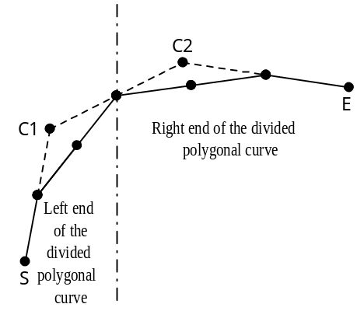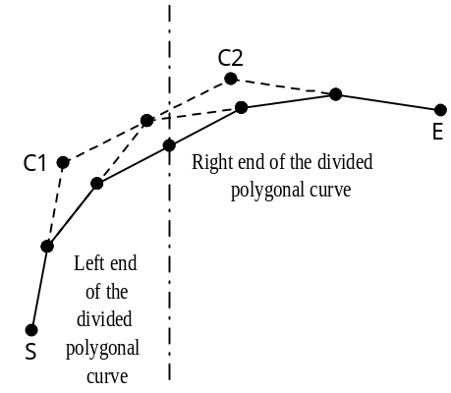

c) d)
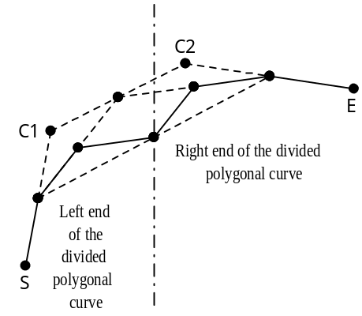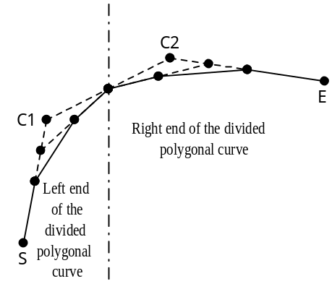

Sub-question 2
From the answer group below, select the correct condition for ending the recursive division processing.

Answer group:
a) When each of the three line segments of the polygonal curve becomes longer than the length given by the parameter len.
b) When each of the three line segments of the polygonal curve becomes shorter than the length given by the parameter len.
c) When each of the three line segments of the polygonal curve becomes short enough to fit within a square with sides of the length given by the parameter len.
d) When one of the three line segments of the polygonal curve becomes longer than the length given by the parameter len.
e) When one of the three line segments of the polygonal curve becomes shorter than the length given by the parameter len.
f) When one of the three line segments of the polygonal curve becomes short enough to fit within a square with sides of the length given by the parameter len.
Sub-question 3
From the answer group below, select the correct responses to insert in the boxes  in the following description of the characteristics of this program.

In case a free curve was drawn with a value of “8” for the parameter len,  caused the function LineTo (which draws straight lines) to be called the largest number of times.
If the same curve were drawn with a value of “16” specified for the parameter len, the number of times the function LineTo was called would be  the number of times the function LineTo was called when the value of Len is “8.”

Answer group for “a”:

a) b)
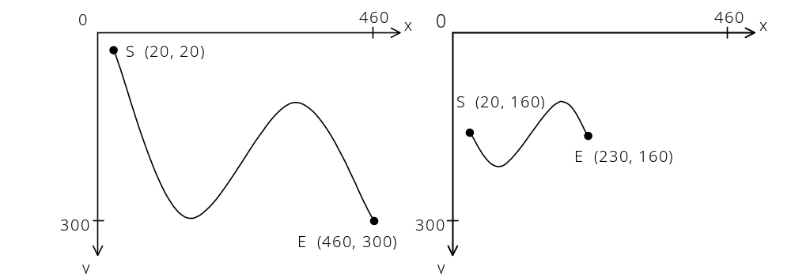

c) d)
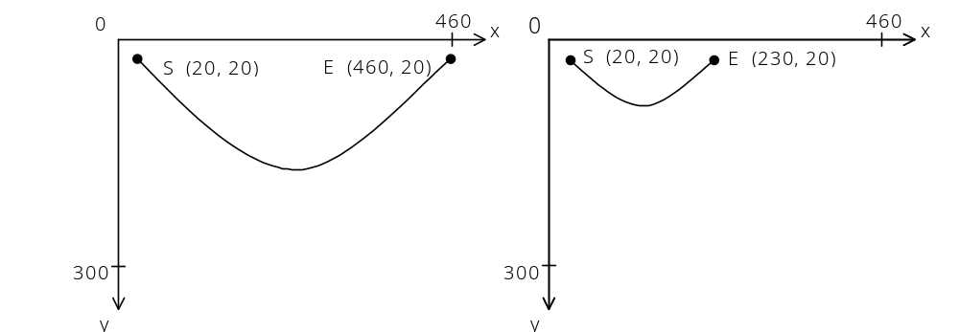

Answer group for “b”:
a) greater than b) equal to c) less than
Sub-question 4
From the answer group below, select the figure that correctly shows the results produced by executing the following program.

int Lines ;
int cx1, cy1 ;
int cx2, cy2 ;

for ( Lines = 0, cx1 = 128, cy1 = 160, cx2 = 256, cy2 = 160 ;
Lines < 16 ;
Lines++, cx1 += 16, cy1 −= 16, cx2 −= 16, cy2 += 16 ) {
DrawCurve( 50, 160, cx1, cy1, cx2, cy2, 384, 160, 8 ) ;
}

Answer group:

a) b)
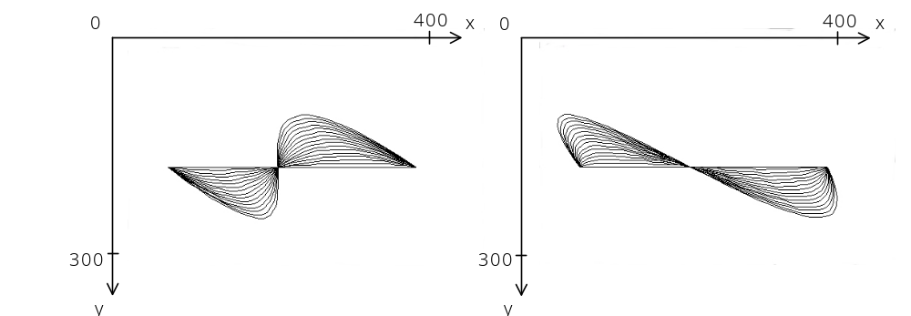

c) d)
